BREADCRUMB

Com plugin breadcrumb navXT

[https://br.wordpress.org/plugins/breadcrumb-navxt/ - reviews](https://br.wordpress.org/plugins/breadcrumb-navxt/#reviews)

para o link da pagina inserir

na guia post type

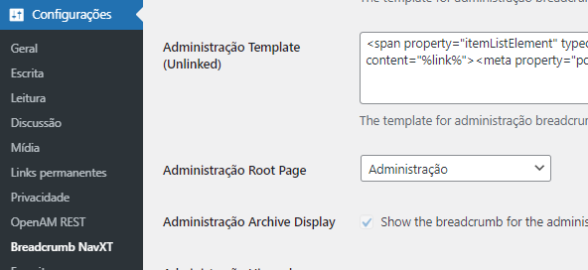

Na pagina

<?php dynamic_sidebar('side_bread'); ?>

Registrar sidebar

function secao_breadcrumb() {

//sidebar sidebar

register_sidebar(

array('name' => 'side_bread',

'id' => 'sidebar-id',

'before_widget' => '<div class="card mt-2">',

'after_widget' => '</div>',

)

);

}

add_action( 'init', 'secao_breadcrumb' );